# **Experiment Design:**

Each server was tested under 2 different conditions, one where there is a burst of clients echoing **1 request** only and another one where the **requests were 10**

Tested in a **Wireless** LAN connection.

**The client**  **program** used for testing was running 2000 processes and 250 threads on each process. Each thread would be running a client making for a total of 50000 “concurrent” clients.

**The servers** each server has a default value for the number of processes / threads to use; nevertheless, in case these are not enough it will keep growing dynamically on demand.

# **Testing:**

The testing during the implementation of the program was not documented. After completion all servers where run in 2 different conditions. Results were really different between all servers when the number of request was low. Nevertheless, when the request increased, all servers seem to be performing the same for the sample client size.

On top of the run experiment. An extra test with a **different** client program was used in order to compare results. Results were unexpected with different servers performing better than on the original experiment. This data was not considered since client implementation might be flawed.

# **TEST LIST**

|  |  |  |  |  |
| --- | --- | --- | --- | --- |
| Test # | Feature Being Tested | Outcome | Pass / Fail | Figure |
| 1 | Threaded Server – 1 Request | Not crashing / Serve Clients | Pass | Fig 1,2,3,4 |
| 2 | Threaded Server – 10 Requests | Not crashing / Serve Clients | Pass | Fig 5,6,7,8 |
| 3 | Select Server – 1 Request | Not crashing / Serve Clients | Pass | Fig 9,10,11,12 |
| 4 | Select Server – 10 Requests | Not crashing / Serve Clients | Pass | Fig 13,14,15,16 |
| 5 | Epoll Server – 1 Request | Not crashing / Serve Clients | Pass | Fig 17,18,19,20 |
| 6 | Epoll Server – 10 Requests | Not crashing / Serve Clients | Pass | Fig 21,22,23,24 |
| 7 | Threaded Server – 1 Request (Different Client) | Not crashing / Serve Clients | Pass | Fig 25 |
| 8 | Select Server – 1 Request (Different Client) | Not crashing / Serve Clients | Pass | Fig 26 |
| 9 | Epoll Server – 1 Request (Different Client) | Not crashing / Serve Clients | Pass | Fig 27 |

Each run on the server counts with 4 figures: 2 figures are from the client and the other 2 are from the server.  
**1st figure** represents the client resources usage   
**2nd figure** represents the client output  
**3rd figure** represents the server resources usage   
**4th figure** represents the server output

**Note:** Each run on a server and client on top of having those images have an output csv file. Found under the csv folder.

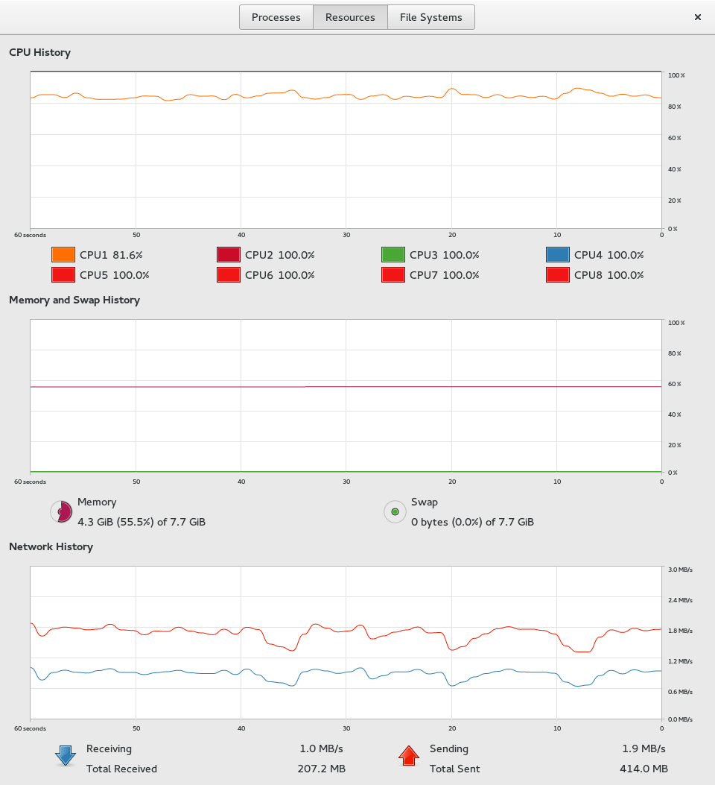

Figure 1

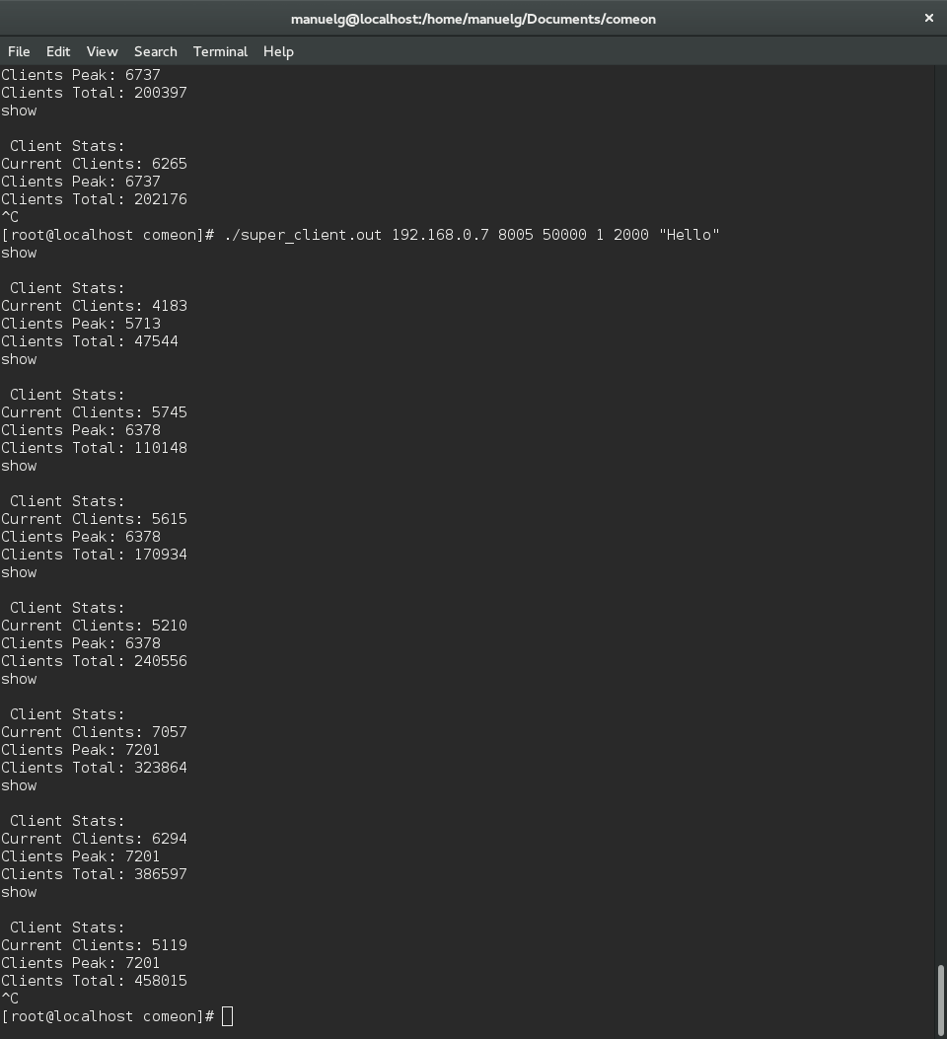

Figure 2

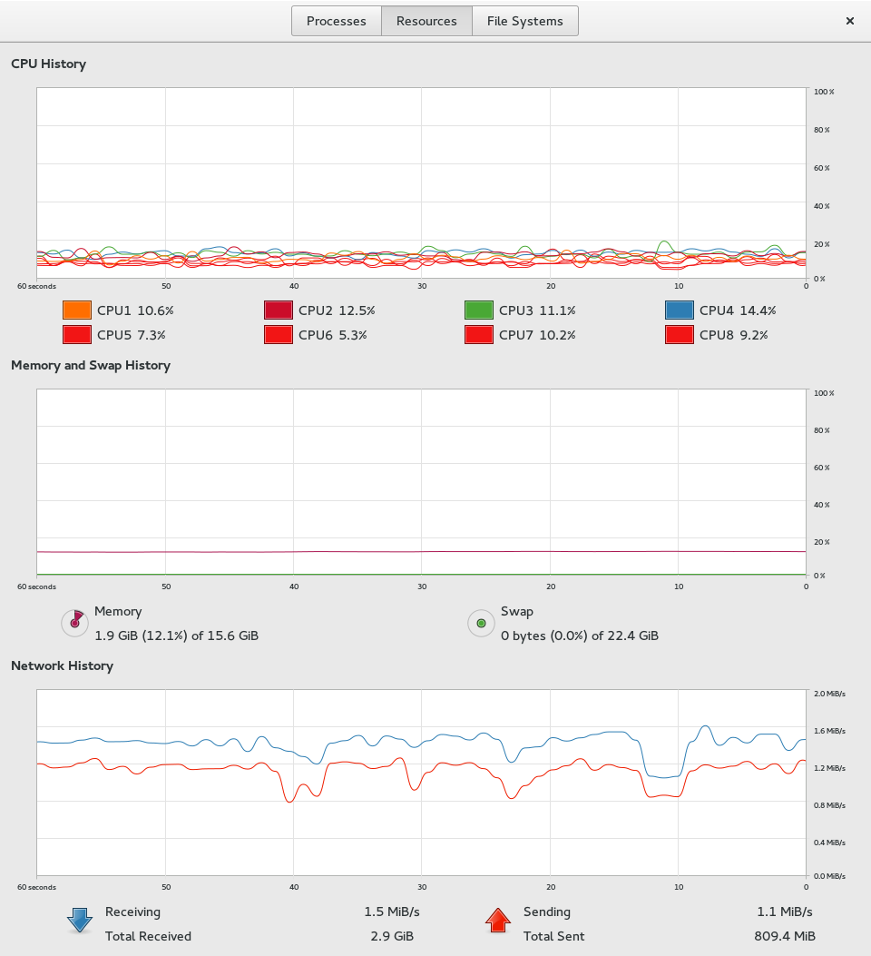

Figure 3

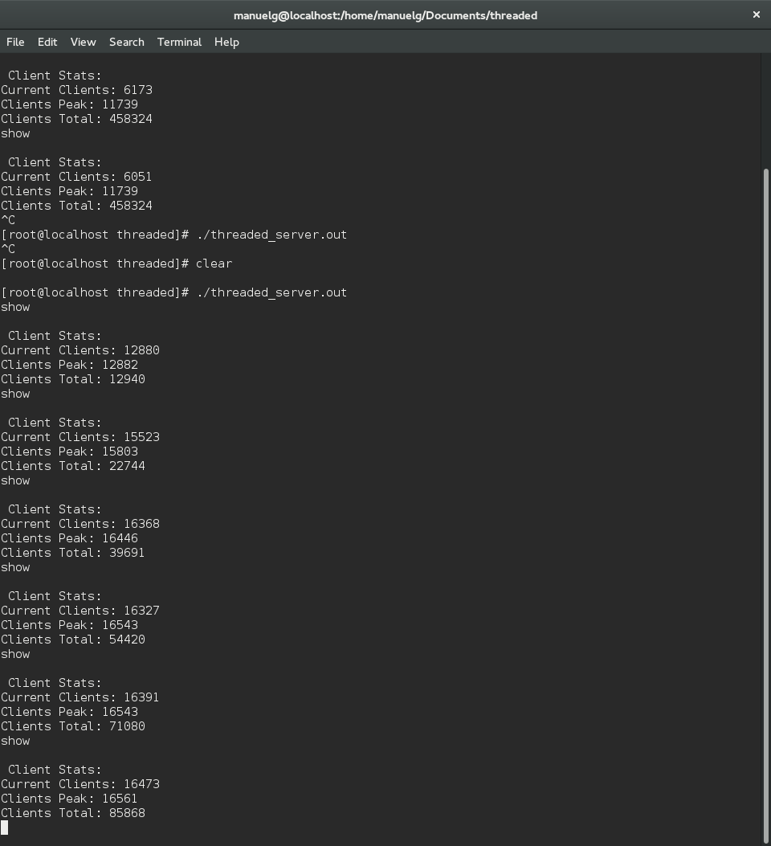

Figure 4

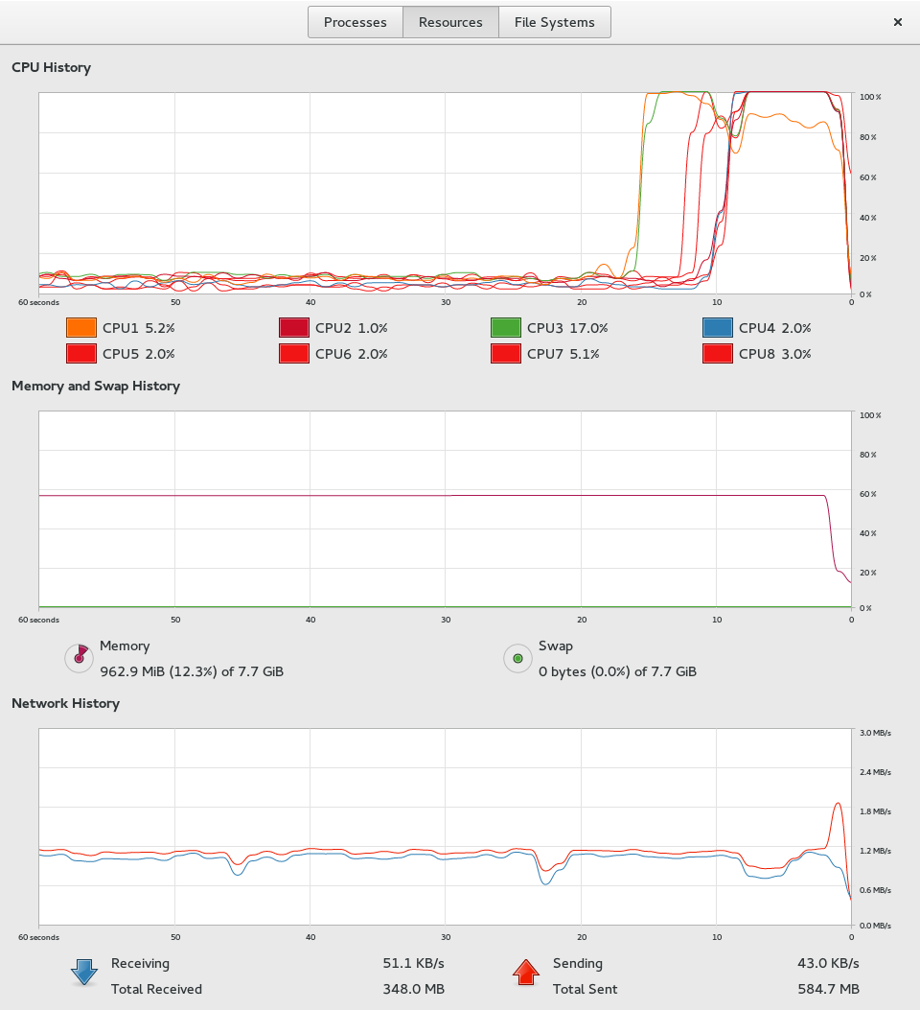

Figure 5

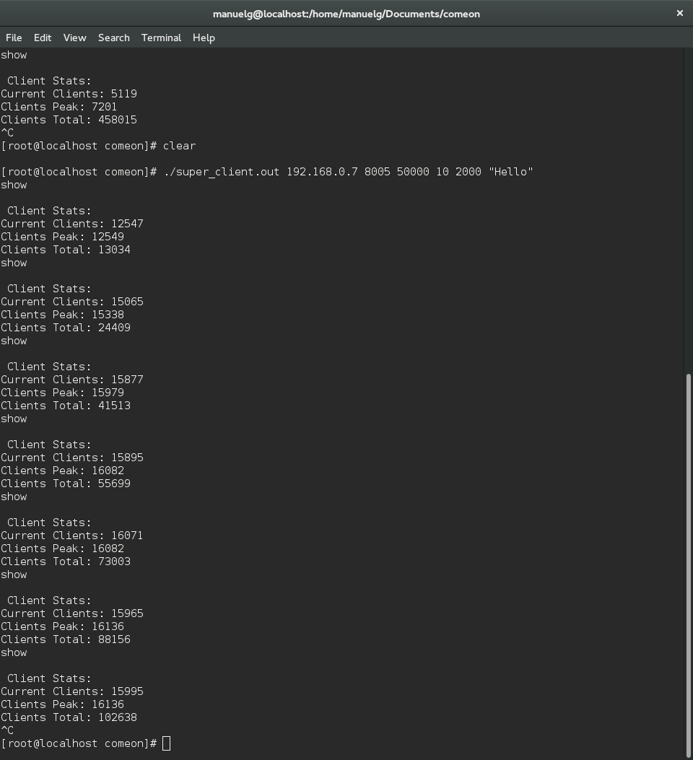

Figure 6

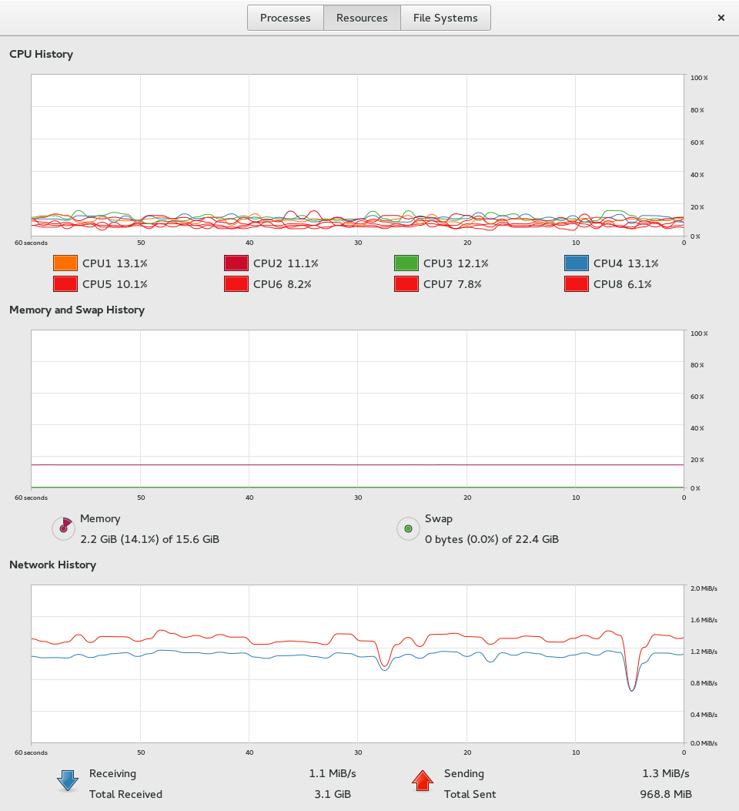

Figure 7

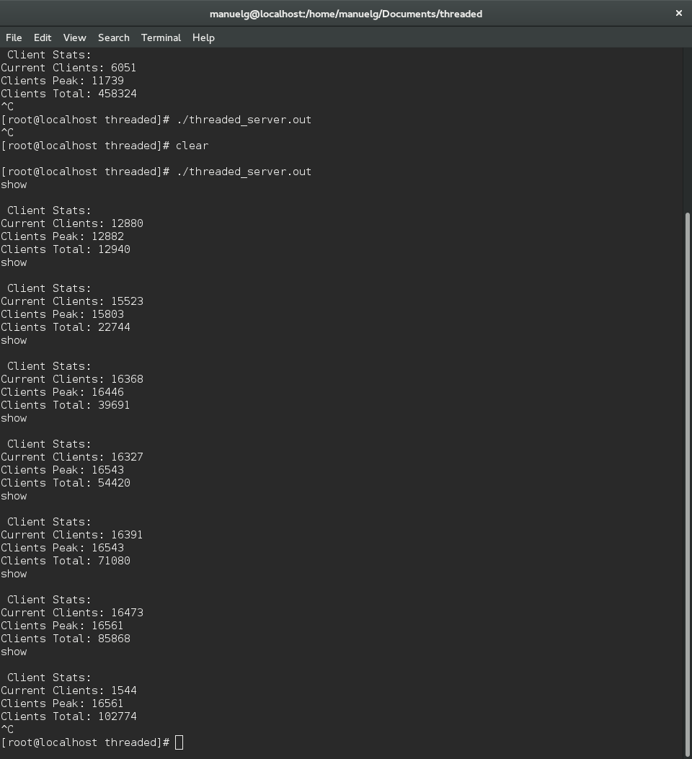

Figure 8

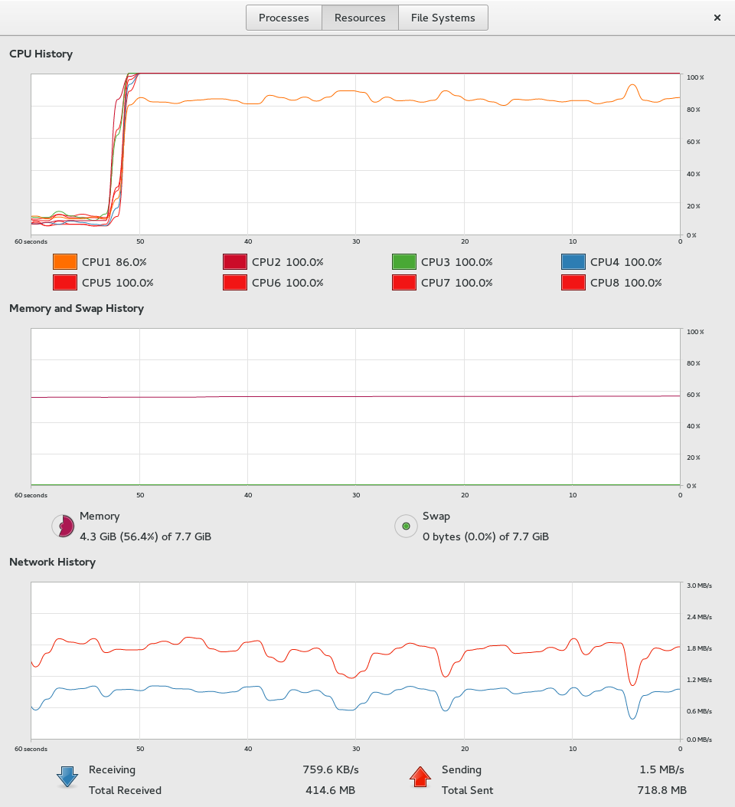

Figure 9

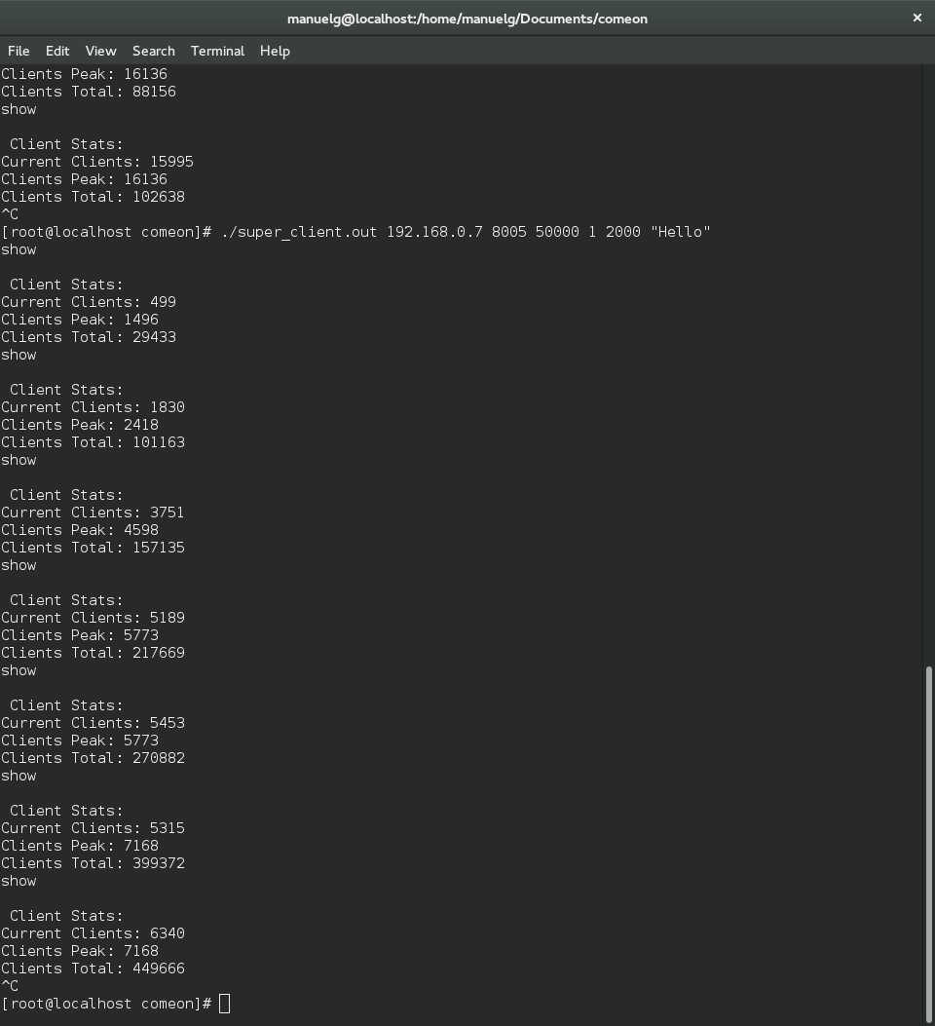

Figure 10

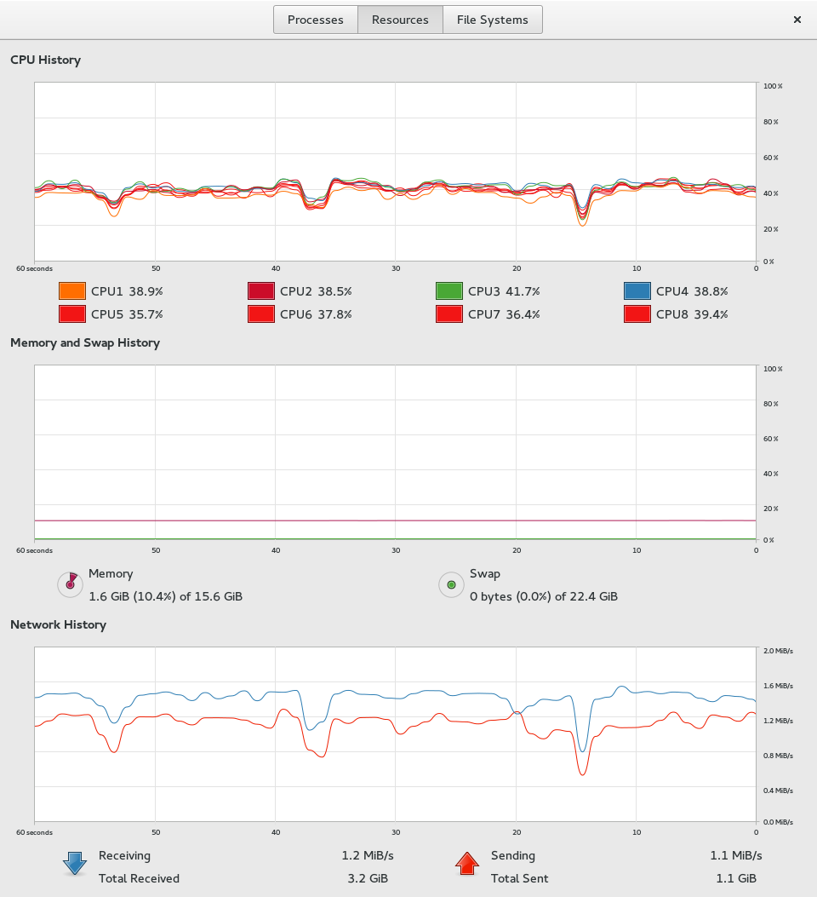

Figure 11

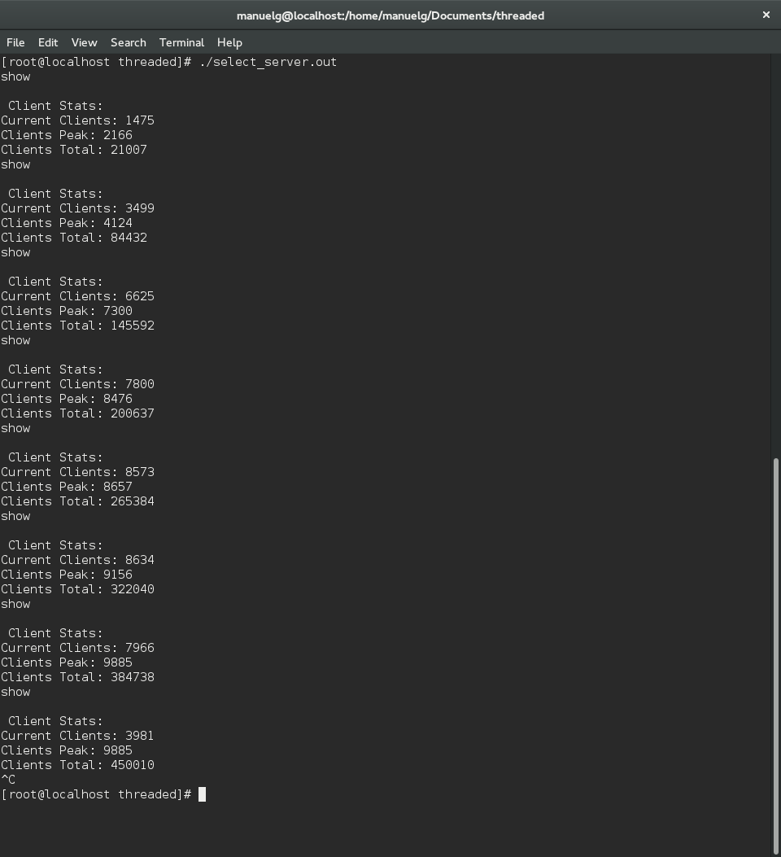

Figure 12

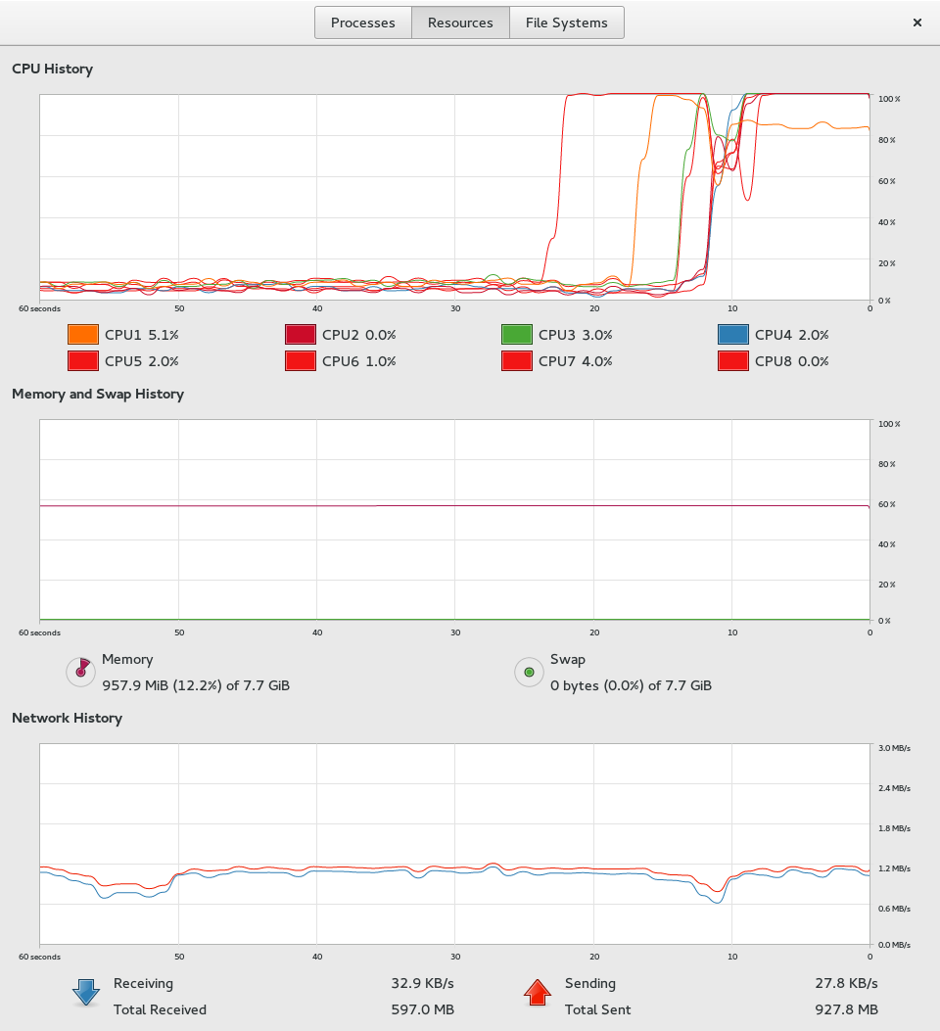

Figure 13

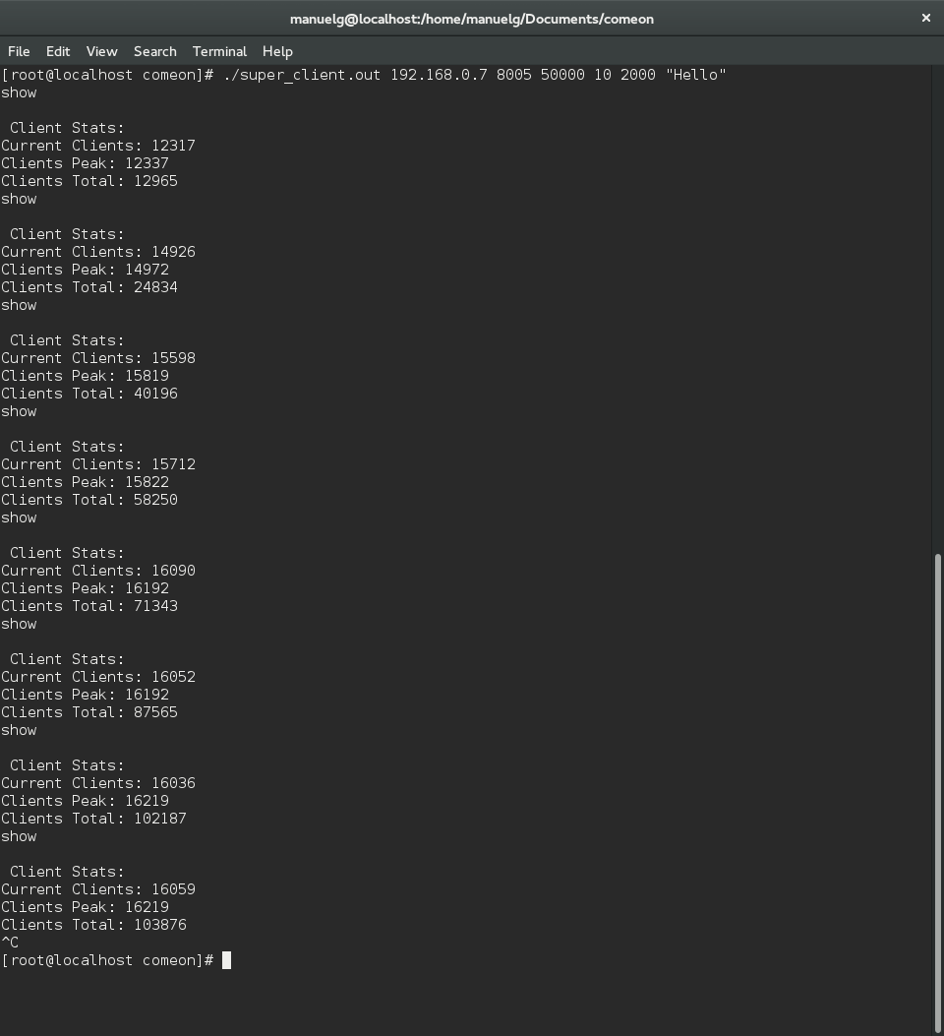

Figure 14

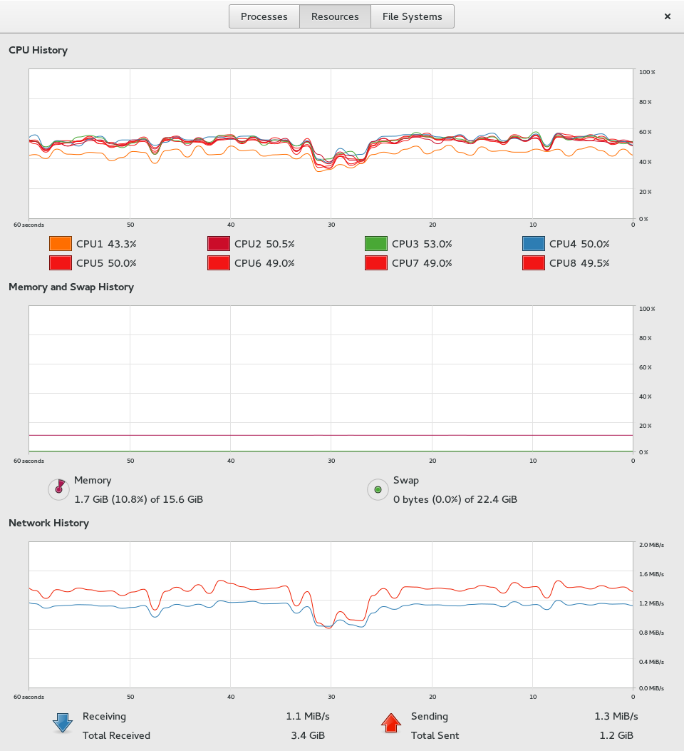

Figure 15

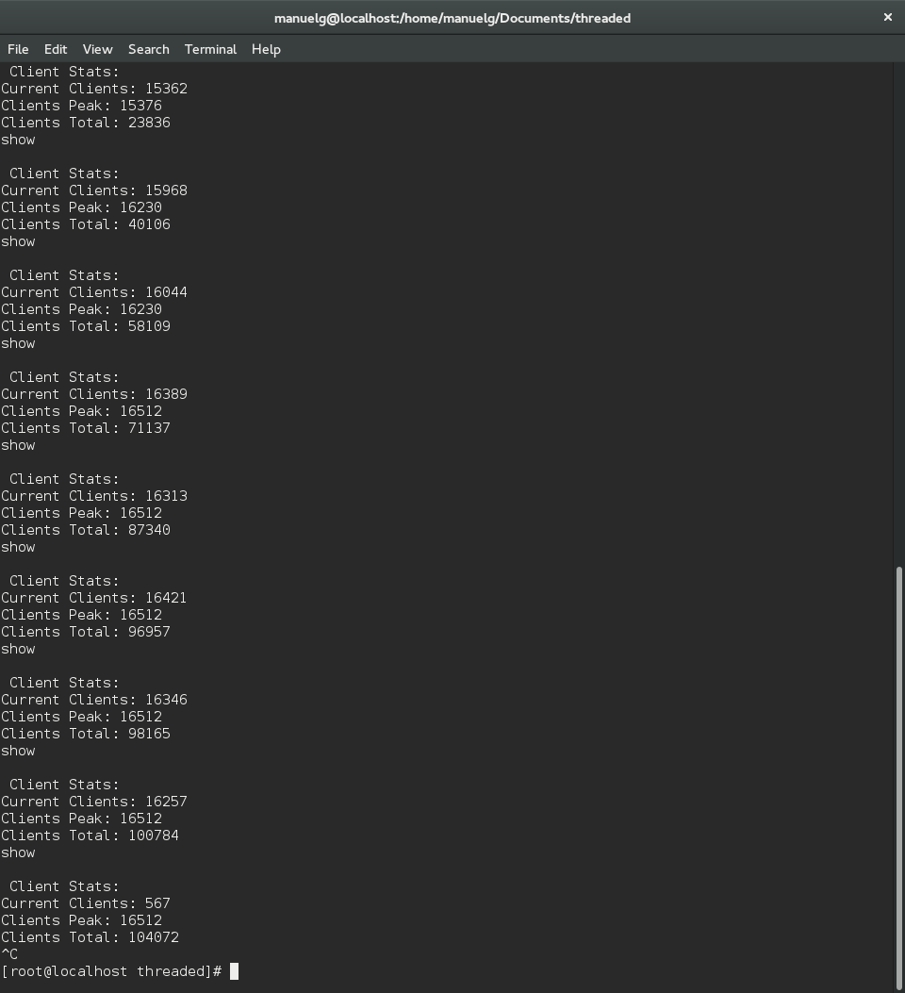

Figure 16

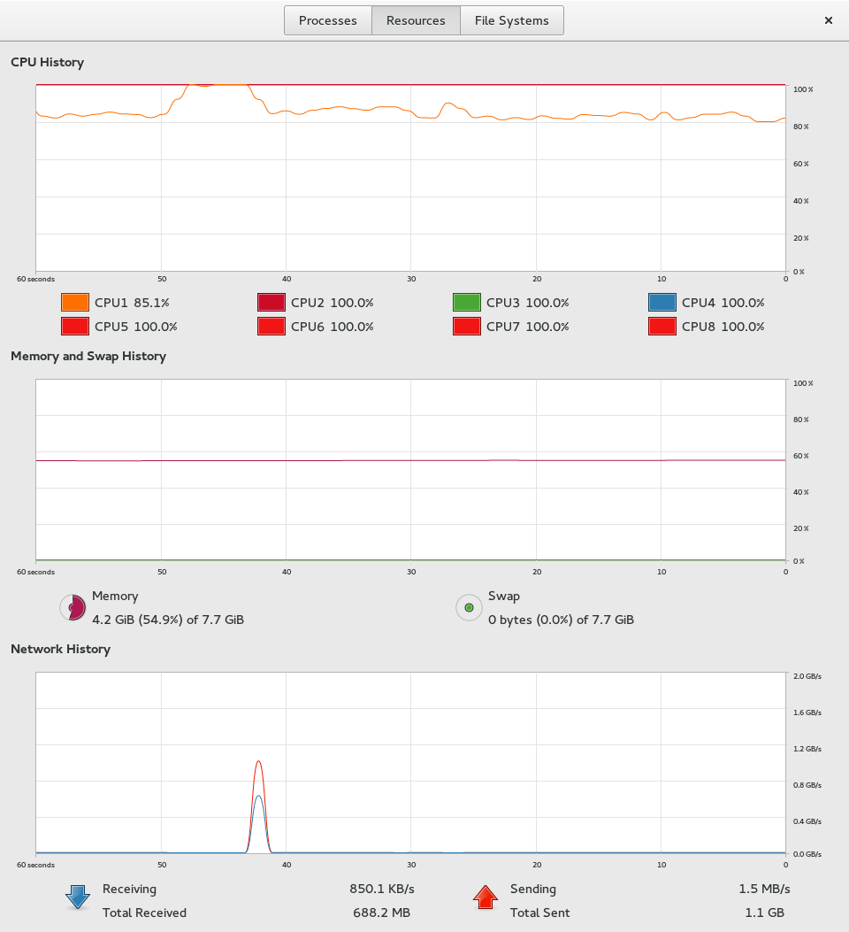

Figure 17

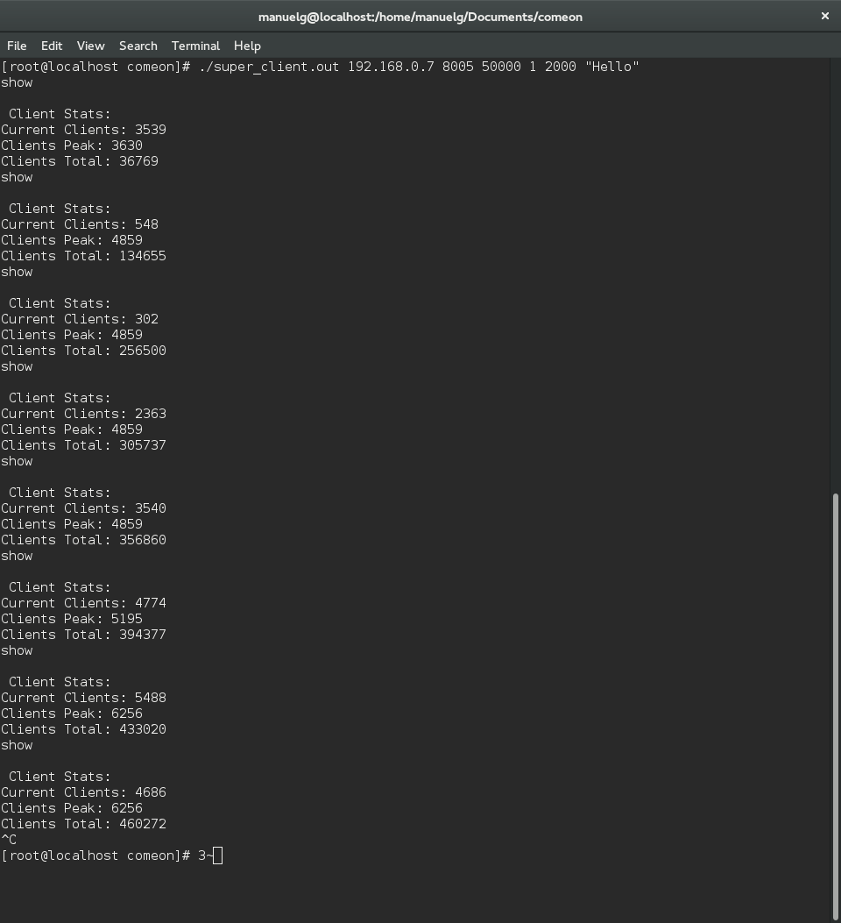

Figure 18

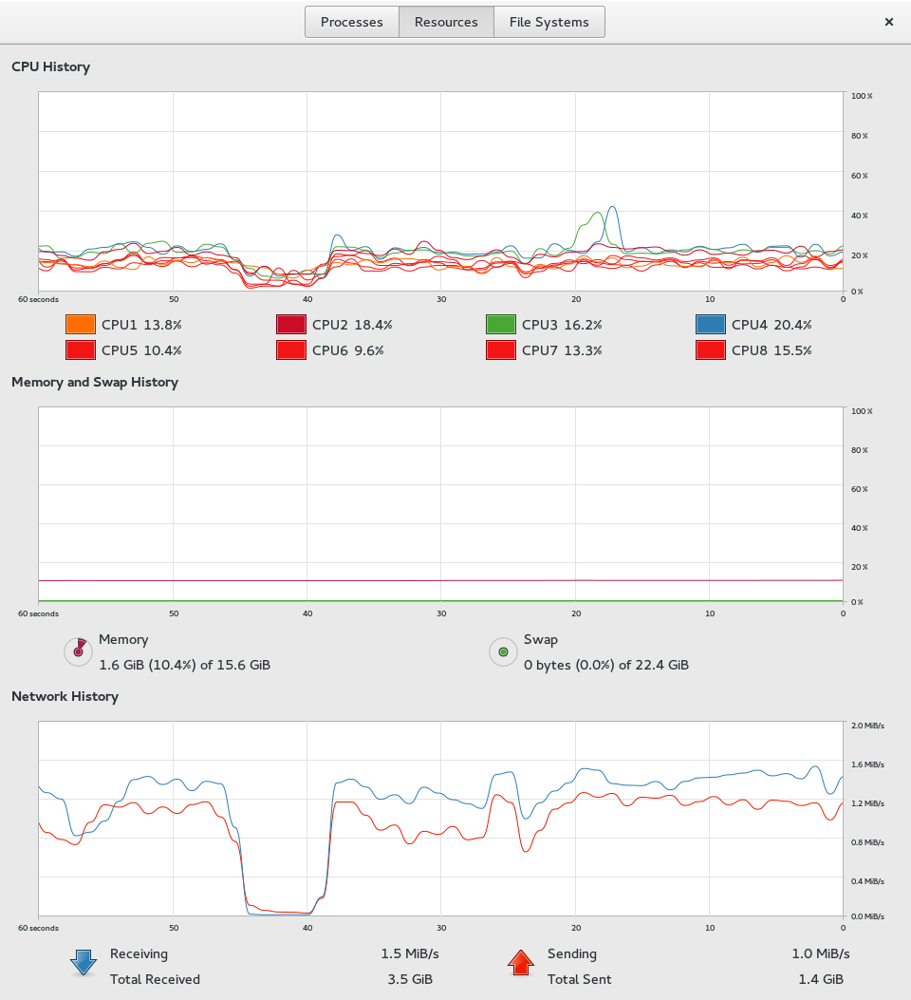

Figure 19

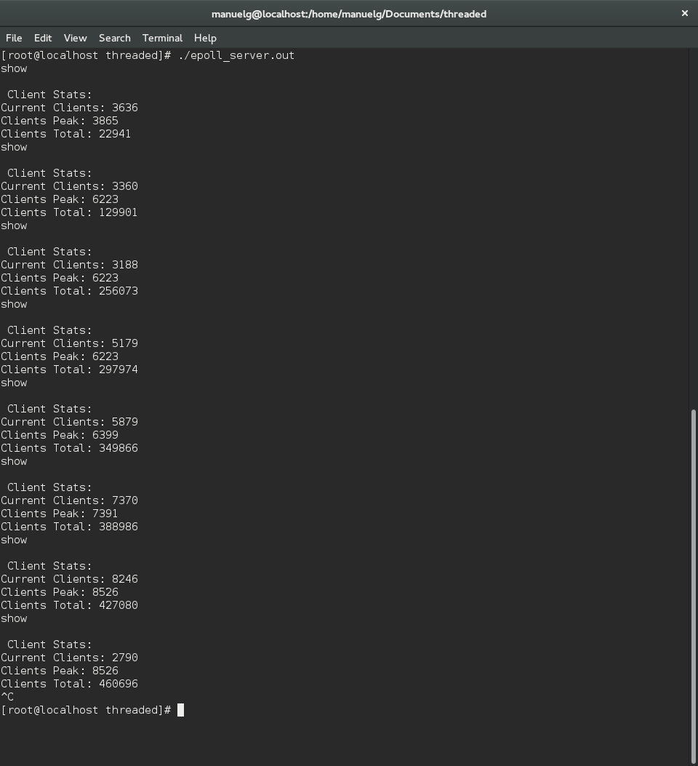

Figure 20

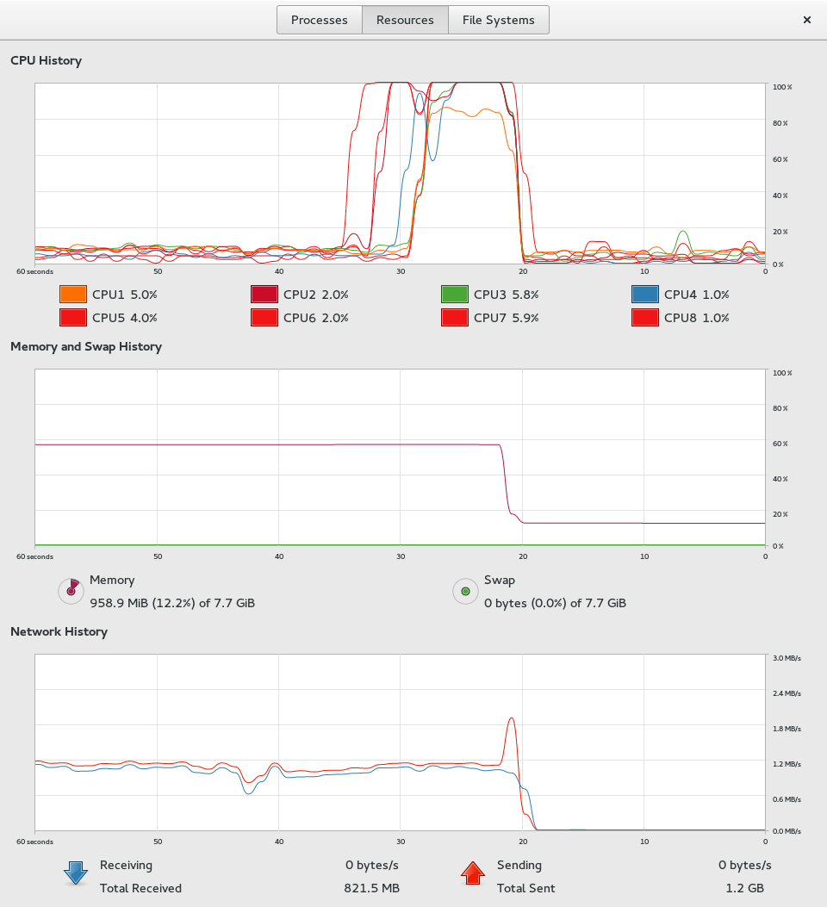

Figure 21

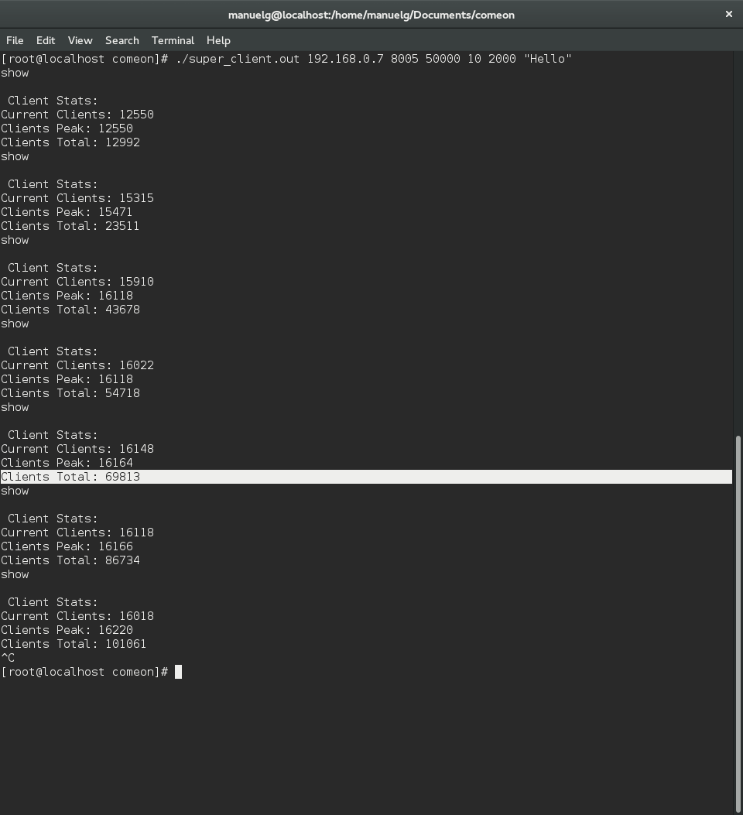

Figure 22

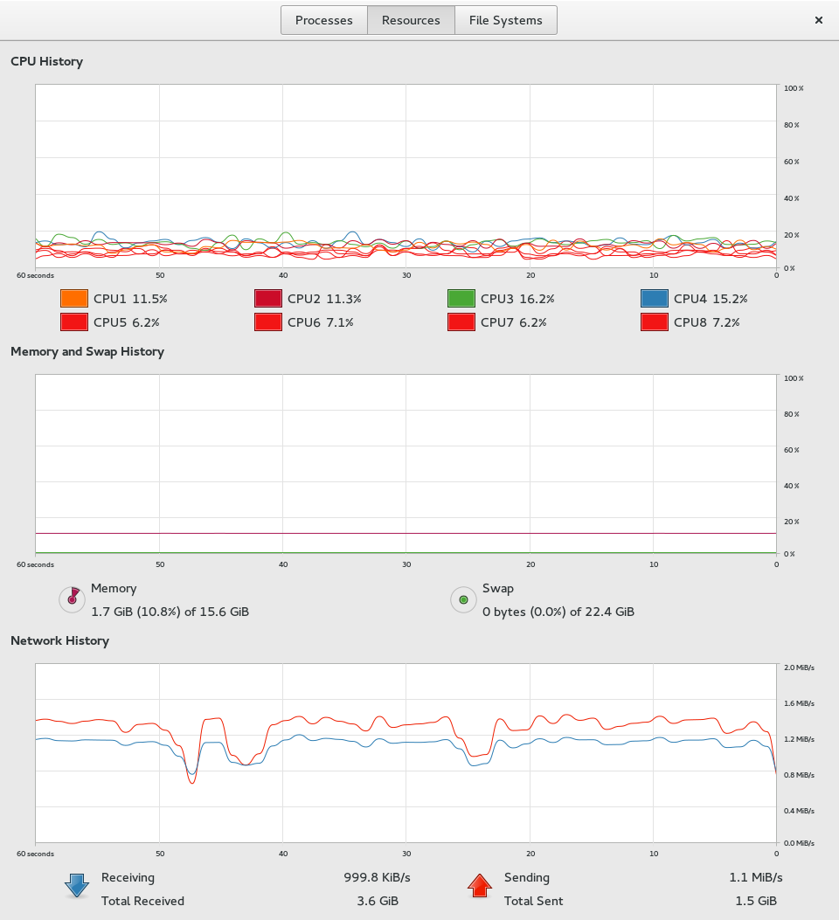

Figure 23

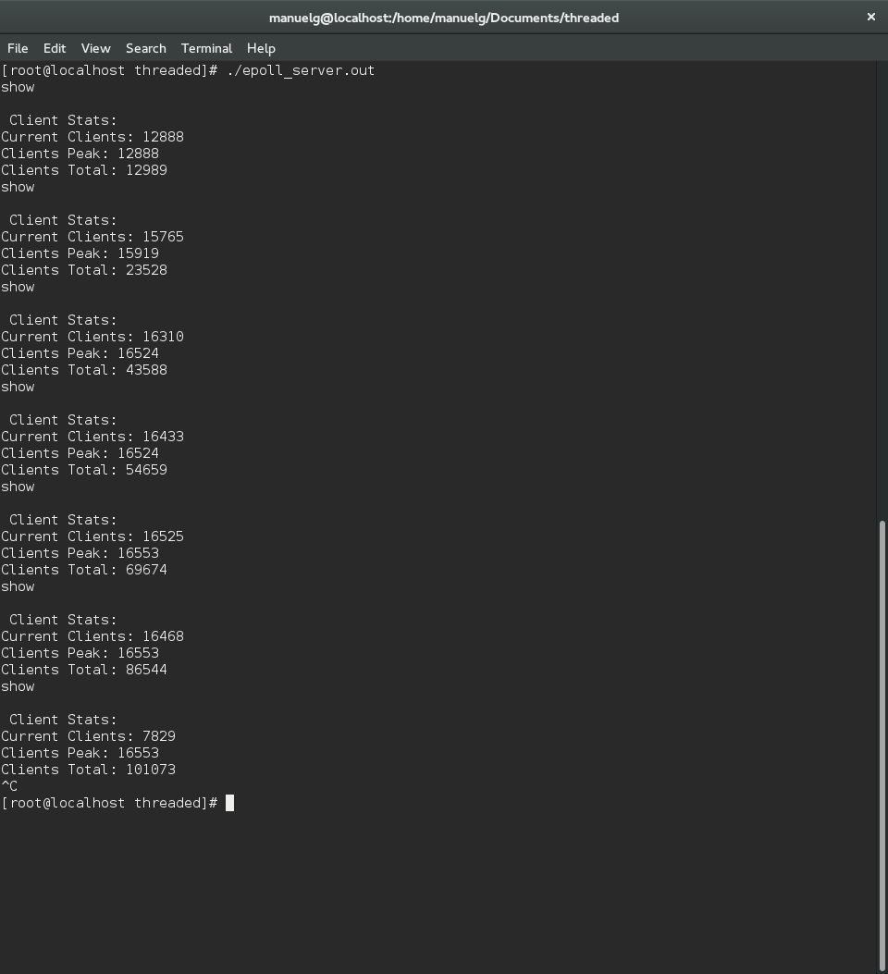

Figure 24

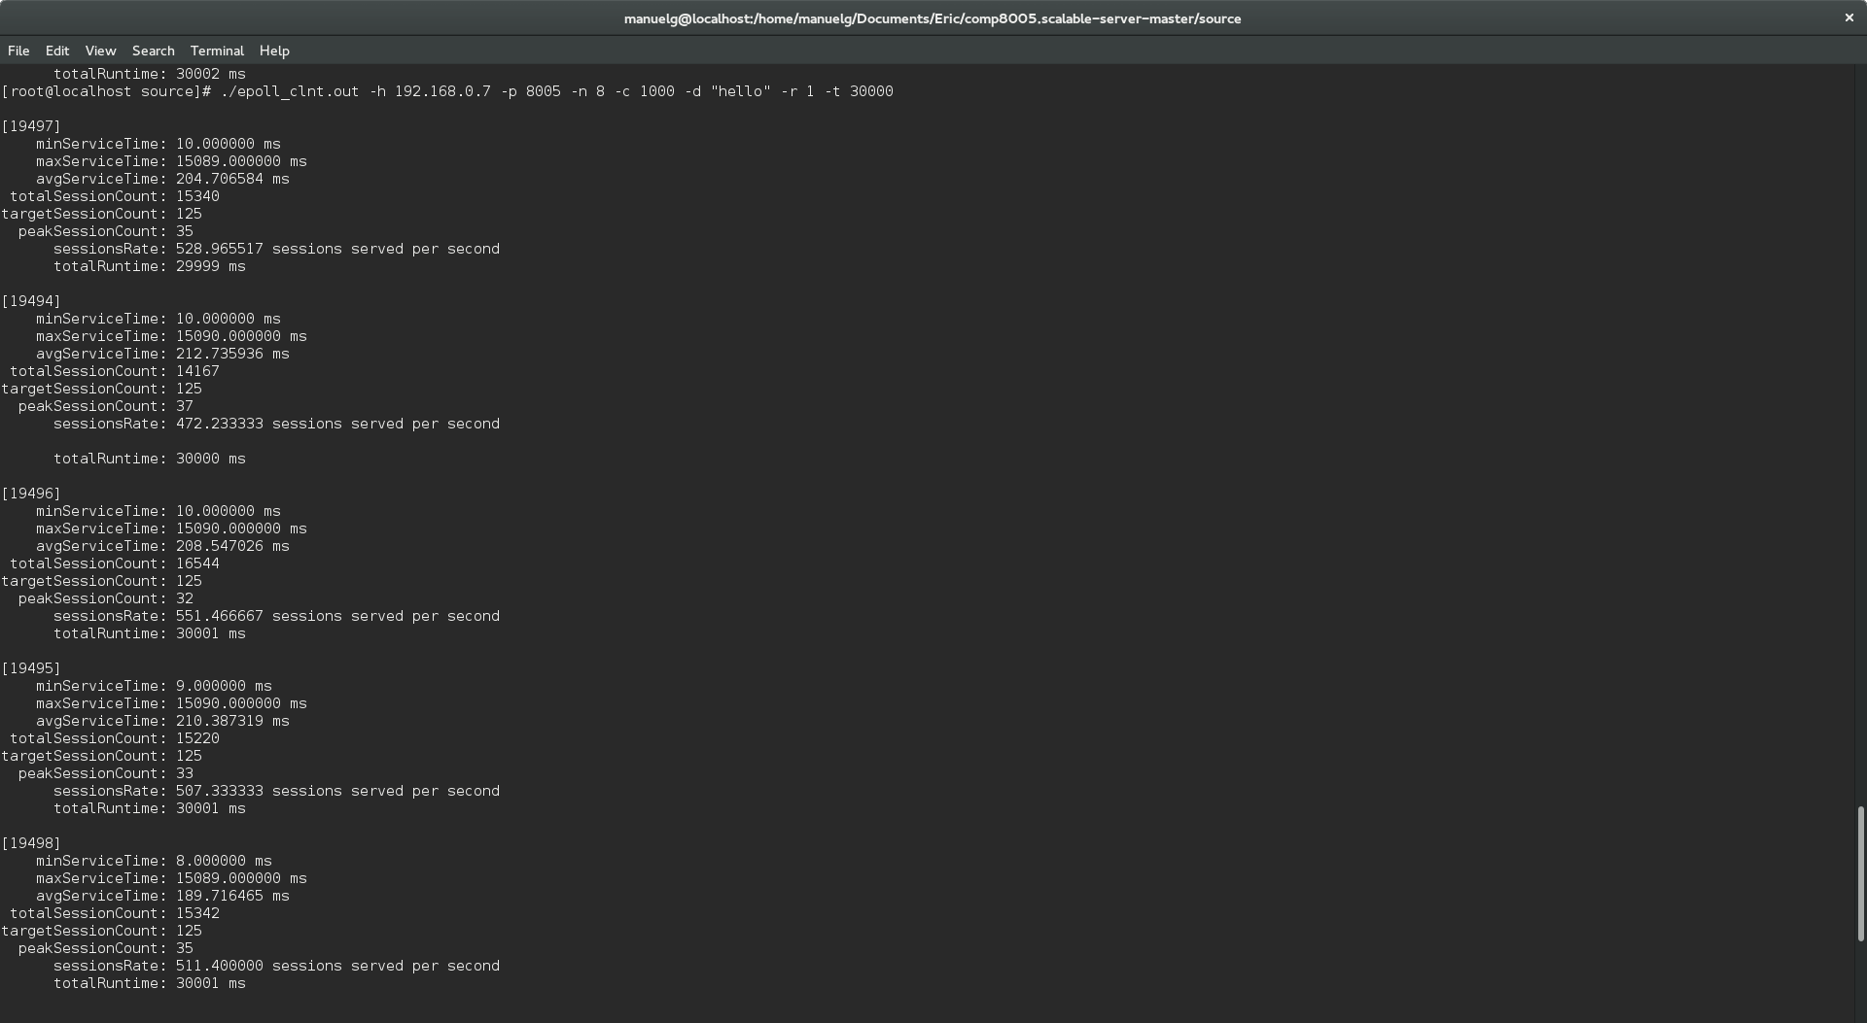

Figure 25

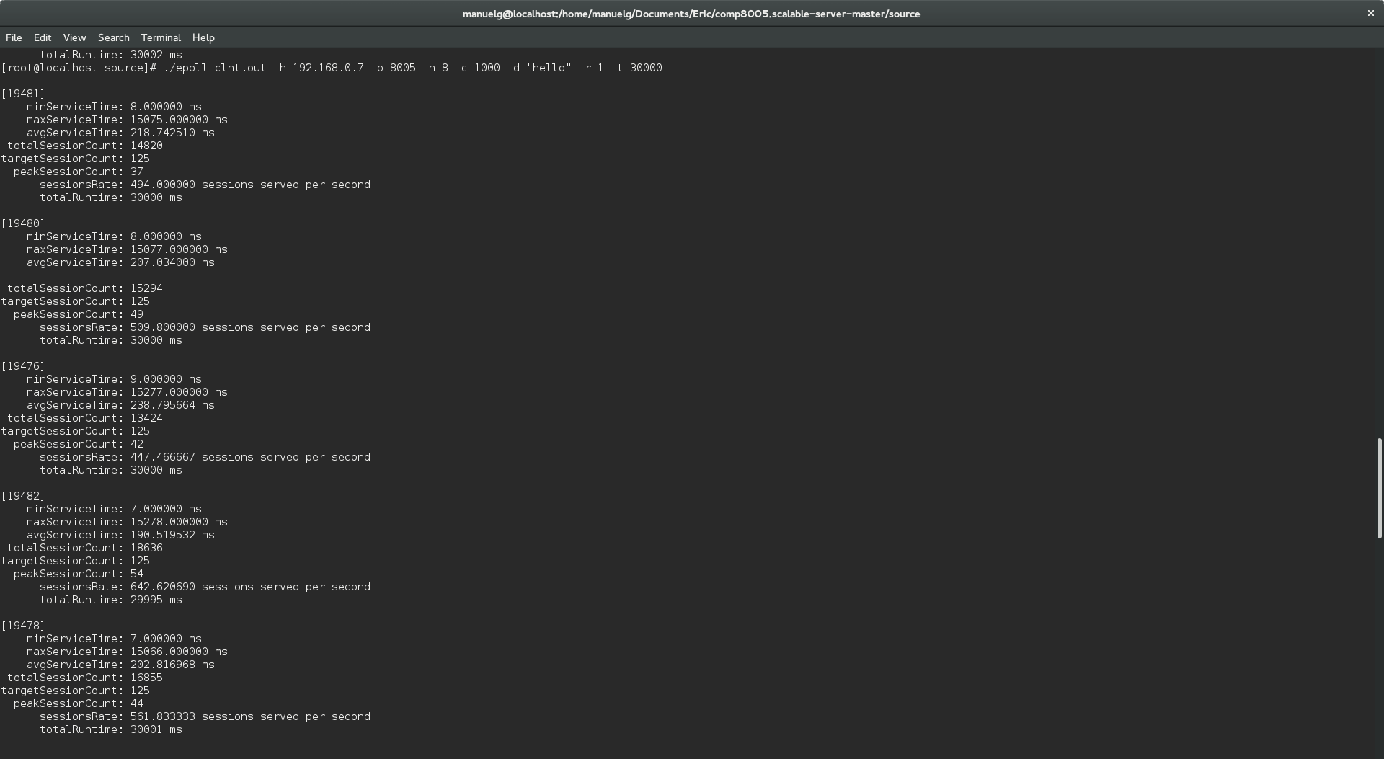

Figure 26

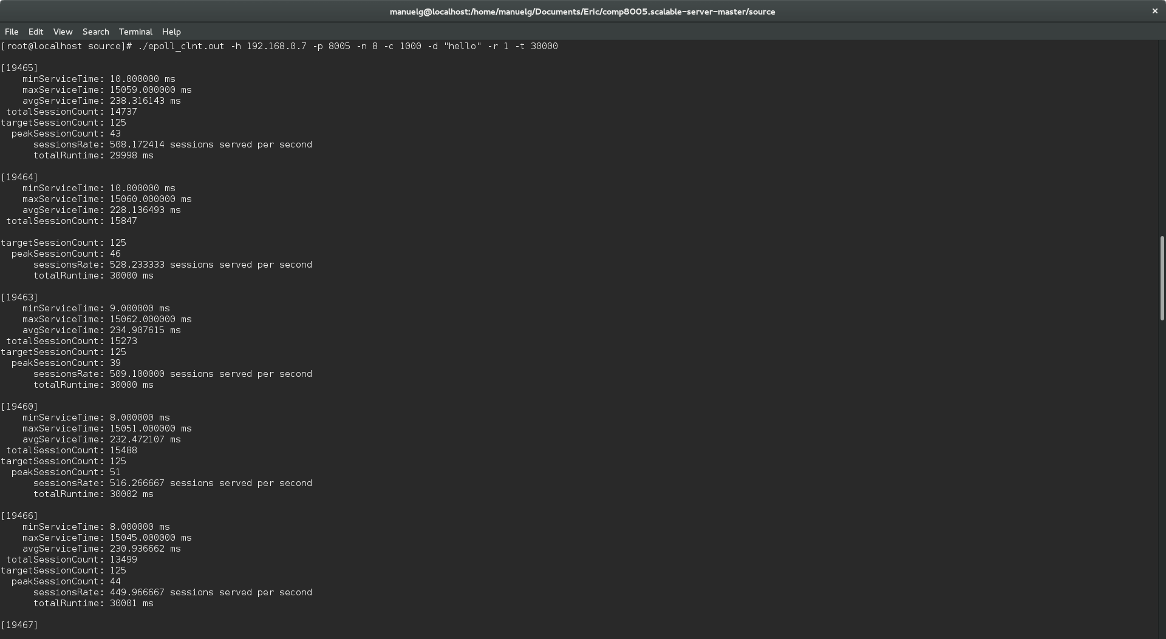

Figure 27